**COMPTE RENDU TD 6:**

**EXERCICE 1 :**

CREATE TABLE Softs (nomSoft CHAR(60), Version CHAR(10))

AS SELECT nomLog, Version,prix FROM Logiciel;

CREATE TABLE PCSeuls (np, nomP, seg, ad, typeP,lieu)

AS SELECT nPoste, nomPoste, IndIP, ad, typePoste, nSalle

FROM Poste ;

WHERE typePoste = 'PCNT' OR typePoste = 'PCWS';

EXERCICE 2 :

1)SELECT nPoste, typePoste FROM Poste WHERE nPoste = 'p8';

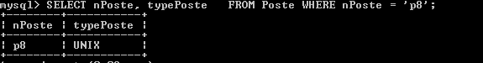

2) SELECT nomLog FROM Logiciel WHERE typeLog = 'UNIX';

3) SELECT nomPoste, indIP, ad, nSalle FROM Poste WHERE typePoste = 'UNIX' OR typePoste = 'PCWS';

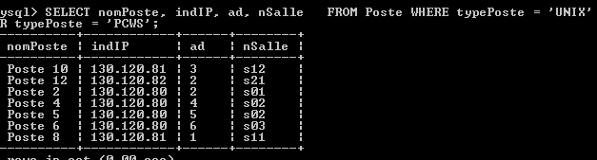

4) 4) SELECT nomPoste, indIP, ad, nSalle FROM Poste WHERE (typePoste = 'UNIX' OR typePoste = 'PCWS')

AND indIP = '130.120.80'

ORDER BY nSalle DESC;

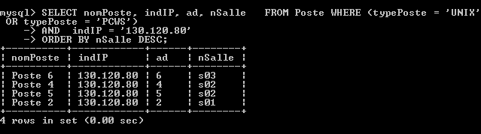

5) SELECT nLog FROM Installer WHERE nPoste = 'p6';

Capture.PNG

6) SELECT nPoste FROM Installer WHERE nLog = 'log1';

Capture.PNG

7) SELECT nomPoste, indIP ||'.'|| ad FROM Poste WHERE typePoste = 'TX';

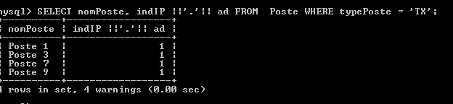

**EXERCICE 3 :**

8) SELECT nPoste, COUNT(nLog) FROM installer GROUP BY (nPoste);

9) SELECT nSalle, COUNT(nPoste) FROM Poste GROUP BY (nSalle) ORDER BY 2;

10) SELECT nLog, COUNT(nPoste) FROM Installer GROUP BY (nLog);

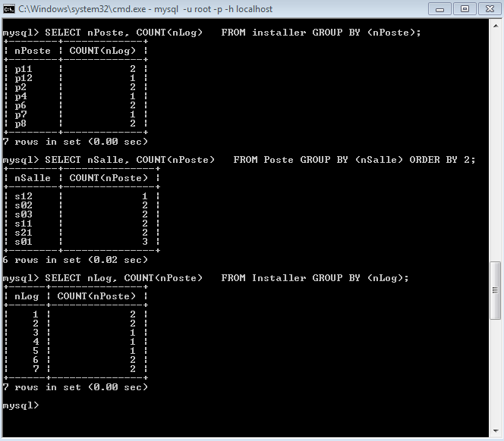

11) SELECT AVG(prix) FROM Logiciel WHERE typeLog = 'UNIX';

12) SELECT MAX(dateAch) FROM Logiciel;

13) SELECT nPoste FROM Installer GROUP BY nPoste HAVING COUNT(nLog)=2;

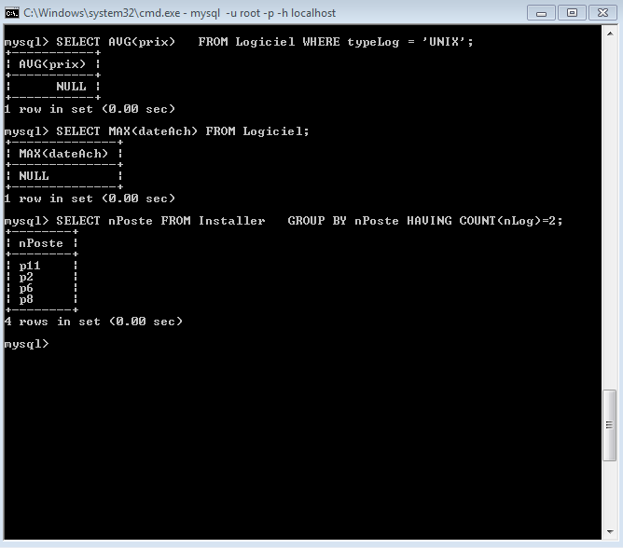

14) SELECT COUNT(*) FROM SELECT nPoste FROM Installer GROUP BY nPoste HAVING COUNT(nLog=2);